Group: S2 Exploring |  | Subject: Perf Arts | Term: 1
Teacher: | Natalie Wood and Steph Kirton
Curriculum: Acting skills and Practitioner’s recap
Term 1 focus: During term 1 we will work through a range of skill-based tasks around key areas of vocal and movement technique. We will also work on building knowledge around a number of practitioners, either introducing students for the first time or recapping prior knowledge and building upon it. We will assess the current level of the student and understand their motivations for choosing performing arts. This knowledge will inform term 2 planning as we begin work towards a BTEC First Award.

 | Theme | Objective | Attendance | How I felt about it (October HT) | How I felt about it (December)
1 | Acting Skills | I can identify and define a range of vocal techniques
2 | Acting Skills | I can apply a range of vocal techniques to a text showing improvement through rehearsal
3 | Acting Skills | I can identify and define a range of movement techniques
4 | Acting Skills | I can select and explore a range of movement techniques in practice
5 | Acting Skills | I can participate in trust building exercises that encourage me to take more risks in my work and offer support and critical reflection to my peers
6 | Practitioners | I can identify at least 3 practitioners and recognise differences and similarities in their approach
7 | Practitioners | I can create short performances that demonstrate different practitioners approaches

Tier Three Keywords:
Vocal colour | Phrasing | Spatial awareness | Practitioner | Articulation | Projection
Inflection | Coordination | Weight placement

Assessment:
Daily Assessment | Substantive Assessment
Type:  Formative assessment happens throughout Perf Arts lessons, questioning, class discussions and reflections both verbally and in student log books. Students are encouraged to reflect on their practical work and others. | Type:  During summative sharing lessons students will monitored against the termly objectives and will be able to measure their final outcome against the weekly progress and intentions they have been working towards and logging in their books.  Students are not expected to master techniques during this phase and summative assessments will help to set personal targets for their continued development.

Recommended Reading:
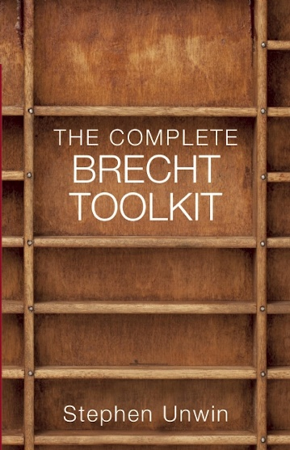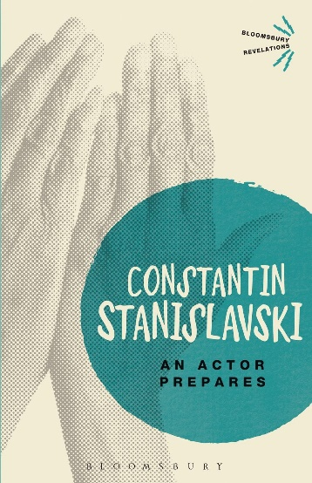

Further resources:
National Theatre resources - https://www.nationaltheatre.org.uk/learn-explore/schools/teacher-resources/?all=true

BBC Bitesize Drama - https://www.bbc.co.uk/bitesize/articles/zd4np4j#zq8yf82

V&A Theatre and Performance archives - https://www.vam.ac.uk/collections/theatre-performance?srsltid=AfmBOoomHjnChVJn9y5bfBwTctyOREHqWD4UNiQMs56ObSdH-KkQSKd-

