Group: BR02 |  |  | Subject: Arts and Technology: cooking | Term: 1
Teacher: |  | Nayna
Curriculum: Deepening KS3
Term 1 focus: The focus for this term is healthy eating. Students will be able to explore different foods and how we use the Eatwell Guide as a way of eating a balanced healthy diet.
1 | Preparing salads, knife skills
2 | Knife/chopping skills
3 | Treating pasta (rapid cool)
4 | Shaping flat breads
5 | Preparing meat following hygiene rules.
6 | Dicing into the same size pieces for marinating and cooking
7
8
9
10
Tier Three Keywords:
Rapid cool | Marinating | Hygiene
Eatwell | Dicing
Healthy eating | Chopping
Recommended Reading:
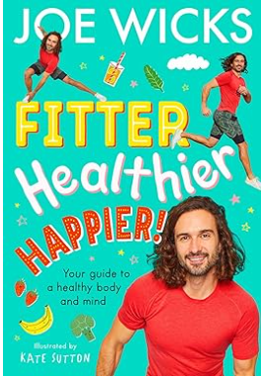
Learn all about your body and mind in this dynamic new fact-filled children’s book from #1 bestselling author and global fitness phenomenon Joe Wicks!
From Joe Wicks – fitness phenomenon and tireless advocate for the power of strong physical and mental health – comes a breakthrough book to get young readers moving and feeling good. Inspiring and motivating, and fully illustrated throughout, Fitter, Healthier, Happier! is an accessible look at the key ingredients to a healthy, happy body: exercise, nutrition, sleep and a healthy mind.
With four information-packed chapters, Joe talks readers through everything they need to know about having a healthy body:
KNOW YOUR BODY: Why do we need a healthy body? Find out what happens to our heart and lungs when we exercise, and how do our skeleton and muscles help us to run, jump and dance.
FUEL YOUR BODY: Join Joe on a tasty tour of everything from carbs to minerals – find out about eating well, nutrition and fuelling your body to ensure you always have plenty of energy.
MOVE YOUR BODY: With handy tips and exercises, grow skills such as flexibility, balance and speed, and get an insight into why these are so important to our physical and mental health. Did you know that exercising every day can boost your brain power?
FOCUS YOUR BODY: A healthy body and a healthy mind go hand in hand! Joe will help you with top-level tips about finding a sport or exercise you love, getting a good night’s sleep, reducing your stress and worry, and finding a calmer mindset.
Written in Joe’s energetic, relatable and motivating voice – which powered so many families through lockdown – this is an informative and fun journey through your body and mind, with plenty of inspiring ideas and activities, and brought to life with amazing black-and-white illustrations by Kate Sutton.
Joe Wicks's book 'Feel Good in 15' was a Sunday Times bestseller w/c 2024-01-15.

