Group: NEM03 |  |  | Subject:  Religious Education | Term: 1
Teacher: |  | James Elliott
Curriculum: Secondary Fundamentals
Term 1 focus:
1 | I can explain the difference between fact, opinion and belief
2 | I can compare religious and scientific views on human origin
3 | I can outline what makes humans unique.
4 | I can describe the qualities and features of a human
5 | I can share my opinion on robots and AI and how it connects to being human
6 | I can connect emotions, free will and law making to being human
7 | I can demonstrate respect for different views, including religious faiths
8 | I can describe what I want for the future of humanity
Tier Three Keywords:
fact | opinion | belief | atheist | theist | agnostic
evolution | creation | Free will | laws | emotions | robots
faith
Recommended Reading:

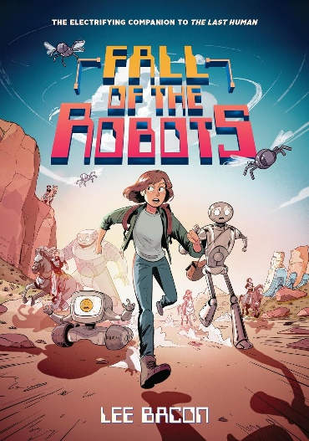

Fall of the Robots (The Last Human #2)

It’s been a few months now since XR_935 met Emma, a human girl who wasn’t supposed to exist. Robots thought they’d eliminated all humans, but some have survived all these years. Now, robots and humans live side by side, and the world is so much better for it. They’ve formed a new society, living together as equals.

