Group: BR01 |  |  | Subject: PEA | Term: 1
Teacher: |  | Rae Salter
Curriculum:
Term 1 focus: Life skills: Safety at home and in the community– students will understand how to stay safe when walking around the local community. They will experience traveling to a variety of locations in the local community, gaining confidence in road safety and navigating in the city. They will understand the potential hazards around the home and how to ensure they are safe whilst at home.

1 | Reinforce understanding of walking on the pavement and staying aware of surroundings.
2 | Navigate more complex pedestrian environments, such as busy city streets.
3 | Demonstrate road safety awareness in varied settings, including rural and urban areas.
4 | Follow directions and maps to navigate safely around the local area.
5 | Plan journeys within the local area, considering time and distance.
6 | Identify the potential hazards in different rooms around the home.
7 | Understand that household products, including medicines and cleaning products, can be harmful.
8 | Understand how to stay safe at home.
9

Tier Three Keywords:
Hazard | Pedestrian | chemical | community | Safety | Navigate
Recommended Reading:

HOME SAFE HOME: A CHILDREN'S BOOK ON HOUSE SAFETY

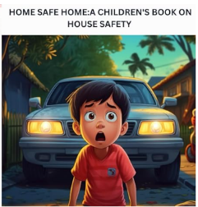
'HOME SAFE HOME: A Children's Book on House Safety" is an engaging and informative book that teaches young readers and their parents about essential safety measures and prevention strategies.

