Group: BR02 |  |  | Subject: Arts | Term: 2
Teacher: |  | Rae Salter
Curriculum: Secondary 1 Deepening
Term 2 focus: Devising Drama/ Watercolour Landscapes
Devising Drama:
In this Drama project, we will discover what ‘Devised Drama’ is and work towards creating our own piece. Students will work as a class to explore a variety of stimuli, including photos, objects, artwork, songs and poetry, as inspiration for original pieces of drama. They will continue to develop their speaking and movement skills and will reinforce knowledge of drama practitioners.

Arts, Watercolour Landscapes:
We will review colour theory and use this knowledge to explore different techniques for painting with watercolours. We will look at and study the works of key landscape artists, including Monet, Van Gogh, Constable and Cézanne. We will create our own watercolour landscape considering composition, colour pallet and painting techniques.
1 | Explore a range of contrasting ideas from the same stimulus
2 | Explain creative decisions and why you made them
3 | Use a stimulus to generate improvised story
4 | Share work at different stages of its progress
5 | Share final work in a chosen form
6 | Know which colours are primary (Red, Blue, Yellow) and which are secondary (Orange, Green, Purple).
7 | Know which two primary colours can be combined to make each of the secondary colours.
8 | Experiment with different methods of painting with watercolour, acrylic paint and different brush techniques examining texture.
9 | Explore and create studies of key landscape from artists such as Monet, Van Gogh, Constable and Cézanne.
10 | Draw and paint a landscape from a photo reference using watercolour paints.
Tier Three Keywords:
Primary | Secondary | Complimentary | Wash | Drybrush | Gradient
Blend | Landscape | Devise | Stimulus | Gesture | Character
Projection | Blocking | Dialogue
Recommended Reading:

10-Minute Watercolours: Techniques & Tips for Quick Watercolours

By Hazel Soan
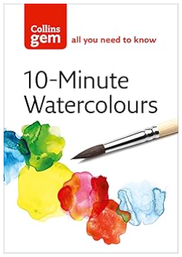
This handy, practical and inspirational little book is perfect for the pocket or art bag. It shows watercolour painters of all levels how to loosen up their paintings and maintain spontaneity by painting simple watercolour studies in no more than 10 minutes.
Written by popular artist Hazel Soan, the book is arranged in three parts: the first section explains all about the equipment you will need; the second section covers techniques and shows what can be achieved with watercolour in a short time span; the third section looks at various subjects that are ideal for painting quickly.
All the essential techniques are covered, focusing particularly on maximizing brushstrokes and exploring colours, and there is useful advice on deciding what to include and what to leave out. With helpful chapters on painting a wide range of subjects – people, landscapes, seascapes, buildings, gardens, flowers and still life – this little guide is ideal for quick reference when working in the studio or out in the field.

