Group: S2 (E) |  |  | Subject: Music | Term: 2
Teacher: |  | Rae Salter
Curriculum: Secondary Two Exploring
Term 2 focus: GCSE Music:
Component 1: Performing
Students will continue developing Their vocal performance skills, with a focus on vocal warm-ups and breathing techniques.
Component 2: Composition
Students will develop the skills needed to complete the composition component for GCSE music. They will gain confidence using both Garageband and Musescore as tools for composition, and continue to develop their Music Theory knowledge from Term 1. They will also explore different approaches to compositions and begin to create musical ideas from a variety of stimuli.
Component 3: Appraisal
Students will begin to explore the music for the first area of study within this component: Instrumental music 1700-1820. This will include studying the context of western classical music during this time period, and becoming familiar with the two set works for this area of study: Bach Brandenburg Concerto no. 5, 3rd movement and Beethoven Piano Sonata no. 8 in C minor. Students will identify and analyse key features of these pieces including structure and form, instrumentation, stylistic features, key musical elements (i.e. tonality, texture, sonority)and the musical language of the piece. They will continue to develop their critical writing skills with regards to music.
1 | Understand the importance of warning up correctly before singing.
2 | Know a variety of vocal warm ups exercises and lead a full vocal warm up.
3 | Experience singing a variety of songs.
4 | Understand how to use Musescore to write out music in western musical notation.
5 | Understand how to record, synthesise and manipulate sound in GarageBand.
6 | Create original musical ideas in Garageband and/or Musescore.
7 | Explore the context of instrumental music 1700-1820
8 | Confidently identify key musical features of set pieces of instrumental music 1700-1820
9 | Understand key musical terms including Sonority, Pitch, Fugue, Articulation, Unison and Chordal
10 | Confidently discuss and write critically about set musical works.
Tier Three Keywords:
Diaphragm | Head voice | Chest voice | Projection | Pitch | Sonority
Fugue | Articulation | Unison | Dynamics | Rhythm | Structure
Melody | Instrumentation | Texture | Tonality | Timbre | Harmony
Tempo | Chordal
Recommended Reading:

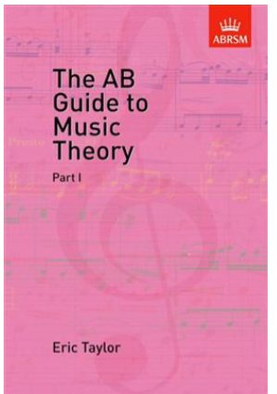
The AB Guide to Music Theory, Part I
The AB Guide To Music Theory is intended to help people learning music to understand how music is written down, what the various signs and symbols denote, and what is meant by the common technical words used by musicians. Arising out of this, it provides an introduction to the basic elements in harmony and musical structure.

