Group:  P16 EW |  |  | Subject:  Horticulture | Term: 1
Teacher: |  | Ally Simpson
Curriculum: Royal Horticultural Society (RHS) Level 1 Introductory Award in Practical Horticulture
Term 2 focus: to provide the learner with the fundamental skills to prepare soil for sowing and planting.
1 | To be able to select and use correct tools
2 | To be able to use equipment for preparing soil
3 | To be able to test the soil
4 | To be able to clear a site of unwanted debris
5 | To be able to load, transport and spread bulky organic matter
6 | To understand the difference between and demonstrate ‘simply digging’ and ‘single digging’
7 | To demonstrate forking and raking
8 | To demonstrate soil consolidation, levelling and tilth production for (a) seeding, broadcast or in drills & (b) planting.
9 | To carry out any necessary preparation of the planting medium according to instructions.
10
Tier Three Keywords:
feature | collaborate | organise | monitor | nutrition | wellbeing
species | soil | routine
Recommended Reading:
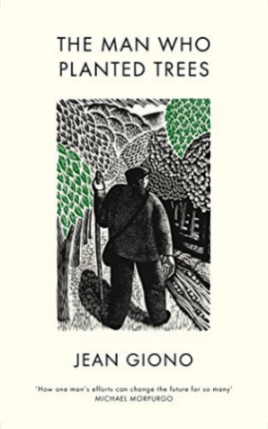
Assessment
Record and annotate steps to prepare soil and propagate seeds.

