Group: Y11/Y12  Animal Care |  |  | Subject: Community and Outdoor Education | Term: 2
Teacher: |  | Abbie Jotham/ Kyle Hall
Curriculum: Animal Care Level 2
Term 1 focus: Health Checks on small animals/ Natural arts.
Students will continue to develop their confidence in handling and caring for the WHF small animals and demonstrate their understanding in independent activities working towards the Level 2 qualification.

1 | List the normal behaviours in a named animal species
2 | Describe the main internal factors that influence animal behaviour
3 | Describe the main external factors that influence animal behaviour
4 | Demonstrate how to handle chosen animals safely
5 | List the appropriate PPE equipment when handling named animals
6 | Know correct handling and restraint skills for a range of animals
7 | Write a plan for providing details of handling and restraining event
Tier Three Keywords:
disease | sequence | pathogen | feature | habitat | ecosystem
behaviour | PPE | environment
Recommended Reading:
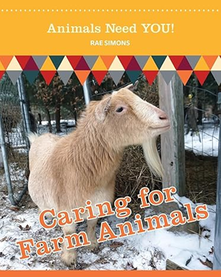

Assessment
Btec level 1/ 2 handling Animals component 1 assessment

