Group: NEC05 |  |  | Subject: Computing |  | Term: 2  06/01/25 – 28/03/25
Teacher: |  | Enike
Curriculum: Computer Science GCSE
Term 2 focus: Layers of Computing Systems and Data Representation
This unit takes learners on a tour through the different layers of computing systems: from programs and the operating system, to the physical components that store and execute these programs, to the fundamental binary building blocks that these components consist of. The aim is to provide a concise overview of how computing systems operate. The last lessons cover two interesting contemporary topics: artificial intelligence and open-source software. In addition, learners to gain the understanding and skills required for the data representation sections of the GCSE computer science exam. Learners will look at binary and hexadecimal numbering systems, how they work, and how to convert between bases.
 | Objective |  |  | Attendance |  | How do you feel about it [end of lesson]
1 | I can explain the difference between a general-purpose computing system and a purpose-built device |  |  | Date When taught |  | G = Good  B = Bad  N = Need more support
2 | I can describe how the hardware components used in computing systems work together in order to execute programs
3 | I can describe what an operating system is and explain how it works
4 | I can recall what the AND, NOT and OR logic gates are
5 | I can create and explain a truth table for all three logic gates (AND, NOT and OR)
6 | I can articulate the use of artificial intelligence
7 | I can recall that in data representation, representations are used to store, communicate and process information
8 | I can explain what binary digits are and give an example of a digit in binary
9 | I can convert a denary number into binary and vice versa
10 | I can recall what hexadecimal means and convert between binary and hexadecimal

Tier Three Keywords:
Denary | Binary | Hexadecimal | Computer system | Hardware | Software
Operating system | AND, NOT and OR gate | Logic gates | Truth table | Computer program | Processing
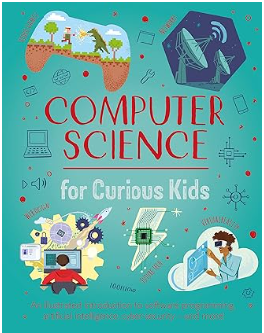Covering Artificial Intelligence, coding, virtual reality and more, this entertaining guide explores the history of computing developments and its role in society today. Students can discover how computing is used in space exploration, how microprocessors work, the famous figures who revolutionised our world and other eye-opening facts. These new concepts pop off the page, thanks to vibrant diagrams and an engaging, energetic prose style.
Recommended Reading

Assessment

Formative | Summative
Formative assessments will be done throughout the Computing lessons.  The start of the lesson will have DNA set out for memory recall. There will be questioning during modelling, encouraging students to explain and justify their working as well as checking work.  There will also be exit tickets used at intervals during the course of study for each module. | Students will be given assessments for each module that will be a summary of what they have been learning. Through these assessments students will be able to showcase their knowledge and how much they are retaining in their long-term memory  This will inform further term planning where lessons are concerned and expose any misconceptions and misunderstandings.

