Group: BR01 |  |  | Subject: Computing |  | Term: 2  06/01/25 – 28/03/25
Teacher: |  | Enike
Curriculum: Computer Science GCSE
Term 2 focus: Data Science and Representations (Going Visual)
learners will be introduced to data science, and by the end of the unit they will be empowered by knowing how to use data to investigate problems and make changes to the world around them. Learners will be exposed to both global and local data sets and gain an understanding of how visualising data can help with the process of identifying patterns and trends. Similarly, when looking at Representations learners will focus on making digital media such as images and sounds, and discover how media is stored as binary code. The unit has a significant practical aspect; students will use design software (GIMP and Audacity in this case) to manipulate images and sounds. This will help them to understand how the underlying principles of digital representations are applied in real settings
 | Objective |  |  | Attendance |  | How do you feel about it [end of lesson]
1 | I can add Data to a table and sort it into the right columns and rows |  |  | Date When taught |  | G = Good  B = Bad  N = Need more support
2 | I can use appropriate software tools to visualise data
3 | I am able to use the appropriate tools to look for patterns and trends in sets of data
4 | I am able to use findings from data sets to give a recommendation for or against a decision based on a prediction
5 | I can recognise instances where large data sets are used in daily life
6 | I can define the terms correlation and Outlier in relation to data trends
7 | I can identify the steps of the investigative cycle when using big sets of data and I can solve a problem by using the steps
8 | I can create a data capture form
9 | I can apply cleaning Techniques to data sets and give reasons why data needs cleansing
10 | I can define key terms such as pixels, resolution and colour depth and describe how an image is represented as a sequence of bits
11 | I can describe the trade off between representation size and perceived quality for digital images
12 | I can describe and assess the creative benefits and ethical drawbacks of digital manipulation [Education for a Connected World]
13 | I can calculate representation size for a given digital sound, given its attributes
14 | I can explain the function of microphones and speakers as components that capture and generate sound.
15 | I can perform basic sound editing tasks using appropriate software and combine them in order to solve more complex problems requiring sound manipulation

Tier Three Keywords:
Big Data | Correlation | Outlier | Patterns | Trends | Investigation Cycle
Pixels | Resolution | Digital Sound | Image | Colour Depth | Bits
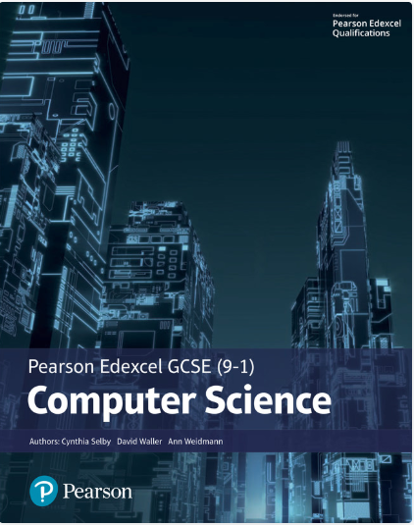The Pearson Edexcel GCSE (9-1) Computer Science 2020 student book offers:
- plenty of practical activities for programming that follow the PRIMM pedagogy
- real world examples and case studies of Computer Science in Action to help make the content relevant and inspiring to students
- worked examples and activities using the PLS or ‘Programming Language Subset’ (Python) for a simple and comprehensive approach to programming
- simplified content to make it as accessible as possible.
This Student Book also helps students concise and productive exam preparation.
Recommended Reading
Assessment

Formative | Summative
Formative assessments will be done throughout the Computing lessons.  The start of the lesson will have DNA set out for memory recall. There will be questioning during modelling, encouraging students to explain and justify their working as well as checking work.  There will also be exit tickets used at intervals during the course of study for each module. | Students will be given assessments for each module that will be a summary of what they have been learning. Through these assessments students will be able to showcase their knowledge and how much they are retaining in their long-term memory  This will inform further term planning where lessons are concerned and expose any misconceptions and misunderstandings.

