Group: Secondary 2 Exploring AB |  |  | Subject: Computing |  | Term: 2  06/01/25 – 28/03/25
Teacher: |  | Enike
Curriculum: BTEC Information and Creative Technology
Term 2 focus: Online Communication
In this term we will continue to look at concepts related to databases, database management systems (DBMS) and Big Data.
Databases: Students learn about the structure and purpose of databases, which store and organize data. They explore different types of databases, such as relational and non-relational databases, and how data is organized into tables, rows, and fields.
Database Management Systems (DBMS): The module introduces DBMS, software that enables users to create, manage, and manipulate databases. Students learn about essential DBMS features, such as querying, updating, and securing data. They also explore SQL (Structured Query Language), which is used to interact with relational databases.
Big Data: The concept of Big Data is explored, including the characteristics of large datasets that are too complex for traditional data-processing methods. Students study how Big Data is collected, stored, processed, and analysed to uncover patterns and trends that can inform decision-making in various industries
 | Outcome |  |  | Attendance |  | How do you feel about it [end of lesson]
 |  |  |  | Date when taught |  | G = Good  B = Bad  N = Need more support
1 | I can recall what is needed to make a structured table for a database
2 | I can explain what a table, record and field is
3 | I understand what a one to one, one to many and many to many database relationships are
4 | I know what URL, HTTP and HTML stand for
5 | I know the difference between a search engine and a web browser and I can give an example of both
6 | I can recall what an online database is and how they work
7 | I can explain what Database Management Systems are, how they are used and an example of a commonly used Database Management System
8 | I can recall what the main characteristics of a parallel, serial and bi directional transmission are
9 | I can give 3 examples of what main threats we have to data
10 | I can tell you the avenues used to manage an E-reputation and speak about the current legislation around data

Tier Three Keywords:
Data | HTTP | Database | Records | Fields | Networks
URL | HTML | Table | Packet Switching | Database Management Systems | Transmission
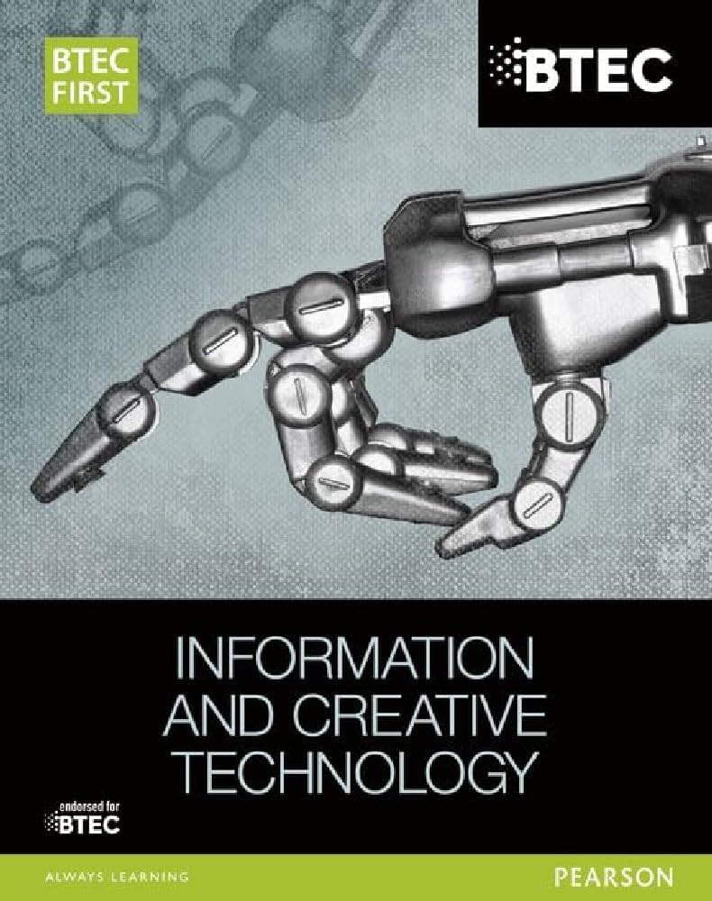
This is the BTEC FIRST book that is related to this module and students would get a lot of useful information from this book that would prepare them for the BTEC Qualification
Recommended Reading:
Assessment

Formative | Summative
Formative assessments will be done throughout the Computing lessons.  The start of the lesson will have DNA set out for memory recall. There will be questioning during modelling, encouraging students to explain and justify their working as well as checking work.  There will also be exit tickets used at intervals during the course of study for each module. | Students will be given assessments for each module that will be a summary of what they have been learning. Through these assessments students will be able to showcase their knowledge and how much they are retaining in their long-term memory  This will inform further term planning where lessons are concerned and expose any misconceptions and misunderstandings.

