Group: EW08 |  |  | Subject: Computing |  | Term: 2  06/01/25 – 28/03/25
Teacher: |  | Enike
Curriculum: Computer Science GCSE
Term 2 focus: Digital Literacy
In this module students will learn the essential skills needed to navigate and use technology effectively and safely. Key areas covered include:
Basic computer skills – Understanding how to log into a computer and navigate through the user interface; students will be able to log in to a computer, open essential office 365 programmes, learn how to save their work and understand how to create folders on their personal drives.

Effective use of programmes: students will get to use and navigate their way through Microsoft Word, PowerPoint and Excel. They will also learn how to write emails and send emails with attachments

Internet Navigation: Using search engines, evaluating online information, and understanding the structure of the internet.
This module will aim to equip students with the knowledge and skills to confidently participate in the digital world, both academically and personally
 | Objective |  |  | Attendance |  | How do you feel about it [end of lesson]
1 | I understand the basic functions of a PowerPoint |  |  | Date When taught |  | G = Good  B = Bad  N = Need more support
2 | I am able to change text, add font, add colours and add images to a PowerPoint
3 | I am able to use slide master, create hyperlinks and add videos and sound to a PowerPoint
4 | I am able to use the Inbuilt PowerPoint Animations and Transitions to modify my PowerPoint slides
5 | I can open up an excel spreadsheet and navigate easily through a spreadsheet
6 | I am able to add text, numbers and formulas to a spreadsheet
7 | I am able to perform basic functions such as addition, subtraction, division and multiplication on Excel
8 | I am able to display patterns of data through chats in excel
9 | I am able to calculate the minimum, maximum and mean in excel with raw data
10 | I am able to open and create a basic word document
11 | I am able to use functions in word such as [text, font style, colour and font size]
12 | I can use the tool bar effectively and know how to use it to manipulate a word document
13 | I can write a formal letter in word
14 | I know how to save a word document and send it to the printer
15 | I can create an email and send it with an attachment.
16 | I can identify what the abbreviations [to, cc and bcc] stand for on an email

Tier Three Keywords:
Big Data | Correlation | Outlier | Patterns | Trends | Investigation Cycle
Pixels | Resolution | Digital Sound | Image | Colour Depth | Bits
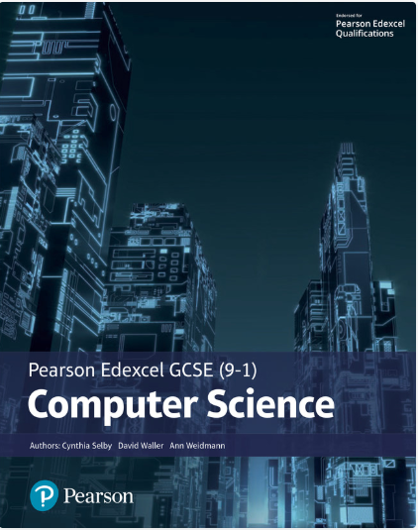The Pearson Edexcel GCSE (9-1) Computer Science 2020 student book offers:
- plenty of practical activities for programming that follow the PRIMM pedagogy
- real world examples and case studies of Computer Science in Action to help make the content relevant and inspiring to students
- worked examples and activities using the PLS or ‘Programming Language Subset’ (Python) for a simple and comprehensive approach to programming
- simplified content to make it as accessible as possible.
This Student Book also helps students concise and productive exam preparation.
Recommended Reading
Assessment

Formative | Summative
Formative assessments will be done throughout the Computing lessons.  The start of the lesson will have DNA set out for memory recall. There will be questioning during modelling, encouraging students to explain and justify their working as well as checking work.  There will also be exit tickets used at intervals during the course of study for each module. | Students will be given assessments for each module that will be a summary of what they have been learning. Through these assessments students will be able to showcase their knowledge and how much they are retaining in their long-term memory  This will inform further term planning where lessons are concerned and expose any misconceptions and misunderstandings.

