Group: EW02 |  |  | Subject: English | Term: 2
Teacher: |  | Alex Bird, Sarah Compai
Curriculum: Secondary Two Exploring
Term 2 focus:

HT1: Short Stories and Creative Writing
HT2: 20th century play and speaking and listening
This term, our studies will centre on developing both reading and writing skills through a comprehensive study of a selection of high-quality short stories and a 20th century play.
When students read and analyse texts, it’s important they identify the most relevant points, including those selected from different parts of the text. This allows them to build a more complete understanding of the material. Encouraging them to explore different layers of meaning—such as how characters' dialogue in a play script reveals their emotions or how specific details in a short story contribute to the theme—can lead to more thoughtful and detailed analysis. Additionally, students should develop explanations of inferred meanings, drawing on evidence from across the text. Students should also comment on structural choices and show some general awareness of the writer’s craft. When analysing language, students should identify key features and offer explanations. This type of analysis deepens their understanding of how language affects the text’s impact.
In their own writing, students should develop relevant ideas with some imaginative detail, helping to engage their reader. They should structure their material clearly, with sentences organized into appropriate paragraphs. Each paragraph should support the main ideas across the text, ensuring logical or chronological links between sections to enhance the overall structure. Using a variety of sentence lengths, structures, and subjects will provide clarity and emphasis, making the writing more dynamic. Lastly, students should choose vocabulary carefully, selecting words for their effect to strengthen their message and keep the reader’s attention.

Reading:
HT1: Structure.
HT2: Discussion of ideas, themes and contemporary issues arising from the text.
KO2 | Across a range of reading most relevant points clearly identified, including those selected from different places in the text
KO3 | Across a range of reading comments develop explanation of inferred meanings drawing on evidence across the text, e.g. ‘you know her dad was lying because earlier she saw him take the letter’
KO4 | Across a range of reading comments on structural choices show some general awareness of writer’s craft, e.g. ‘it tells you all things burglars can do to your house and then the last section explains how the alarm protects you’
KO5 | Across a range of reading various features of writer’s use of language identified, with some explanation, e.g. ‘when it gets to the climax they speak in short sentences and quickly which makes it more tense’
KO6 | Across a range of reading main purpose clearly identified, often through general overview, e.g. ‘the writer is strongly against war and wants to persuade the reader to agree’
Writing:
HT1: Creative
HT2: Writing to support talk
KO1 | Across a range of writing relevant ideas and material developed with some imaginative detail
KO3 | Across a range of writing material is structured clearly, with sentences organised into appropriate paragraphs
KO4 | Across a range of writing paragraphs clearly structure main ideas across text to support purpose, e.g. clear chronological or logical links between paragraphs
KO5 | Across a range of writing a variety of sentence lengths, structures and subjects provides clarity and emphasis
KO7 | Across a range of writing vocabulary chosen for effect

Tier Three Keywords:
Exposition | Climax | Resolution | Structure | Rising Action | Setting
Imagery | Figurative | Hook | Cohesion | Symbolism | Characterisation
Stage directions | Tone | Dramatic irony | Audience | Speaker | Paralinguistic

Recommended Reading:

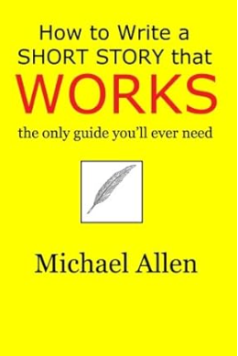
Building on the ideas of great short-story theorists from the past – Edgar Allan Poe, Professor Walter B. Pitkin, and Thomas H. Uzzell – author Michael Allen adds his own fifty years of experience as a writer and publisher to provide a proven technique for success.
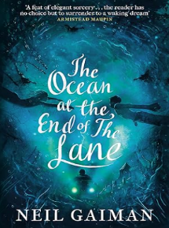
The Ocean At The End Of The Lane is a fable that reshapes modern fantasy: moving, terrifying and elegiac - as pure as a dream, as delicate as a butterfly's wing, as dangerous as a knife in the dark.

