Group: EW06 |  |  | Subject: English | Term: 2
Teacher: |  | Alex Bird, Sarah Compai
Curriculum: Secondary Two Exploring
Term 2 focus:

HT1: Short Stories and Creative Writing
HT2: 20th century play and speaking and listening
This term, our studies will centre on developing both reading and writing skills through a comprehensive study of a selection of high-quality short stories and a 20th century play.
When students read and analyse texts, it’s important they use relevant quotes and references to support their ideas. This helps demonstrate a deeper understanding of the material. Encouraging them to explore different layers of meaning—such as how characters' dialogue in a play script reveals their emotions or how specific details in a short story contribute to the theme—can lead to more thoughtful and detailed analysis.
Students should also pay attention to how the structure of a text shapes the development of characters or ideas. By noticing how these elements evolve over time, they can better understand the writer’s purpose. In their own writing, students need to maintain a clear and consistent voice, whether they are expressing an opinion or developing a character. Organization is key—students should ensure their writing flows logically, with each paragraph building on the next. Using a mix of sentence structures and a varied vocabulary will keep the reader engaged and strengthen their arguments. Even if every word choice isn’t perfect, a wide range of vocabulary enhances the overall impact of their writing.

Reading:
HT1: Structure.
HT2: Discussion of ideas, themes and contemporary issues arising from the text.
KO2 | Across a range of reading commentary incorporates apt textual reference and quotation to support main ideas or argument
KO3 | Across a range of reading comments securely based in textual evidence and identify different layers of meaning, with some attempt at detailed exploration of them, e.g. explaining the association of different words in an image, or exploring connotations in a political speech or advertisement
KO4 | Across a range of reading some detailed exploration of how structural choices support the writer’s theme or purpose, e.g. tracing how main ideas/characters develop over the text as a whole
KO5 | Across a range of reading some detailed explanation, with appropriate terminology, of how language is used, e.g. tracing an image; identifying and commenting on patterns or structure in the use of language; or recognising changes in language use at different points in a text
KO6 | Across a range of reading viewpoint clearly identified and explanation of it developed through close reference to the text, e.g. ‘you know it’s told from Eric’s point of view even though he doesn’t use the first person’
Writing:
HT1: Creative
HT2: Writing to support talk
KO1 | Across a range of writing convincing, individual voice or point of view established and mostly sustained throughout, e.g. authoritative expert view, convincing characterisation, adopting a role
KO3 | Across a range of writing material is clearly controlled and sequenced, taking account of the reader’s likely reaction, e.g. paragraphs of differing lengths, use of flashback in narrative, anticipating reader’s questions
KO4 | Across a range of writing construction of paragraphs clearly supports meaning and purpose, e.g. paragraph topic signalled and then developed, withholding of information for effect, thematic links between paragraphs
KO5 | Across a range of writing controlled use of a variety of simple and complex sentences to achieve purpose and contribute to overall effect
KO7 | Across a range of writing range of vocabulary generally varied and often ambitious, even though choices not always apt

Tier Three Keywords:
Exposition | Climax | Resolution | Structure | Rising Action | Setting
Imagery | Figurative | Hook | Cohesion | Symbolism | Characterisation
Stage directions | Tone | Dramatic irony | Audience | Speaker | Paralinguistic

Recommended Reading:

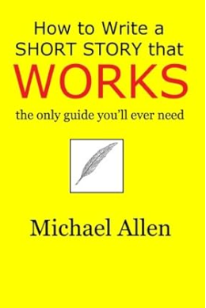
Building on the ideas of great short-story theorists from the past – Edgar Allan Poe, Professor Walter B. Pitkin, and Thomas H. Uzzell – author Michael Allen adds his own fifty years of experience as a writer and publisher to provide a proven technique for success.
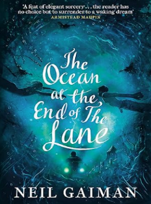
The Ocean At The End Of The Lane is a fable that reshapes modern fantasy: moving, terrifying and elegiac - as pure as a dream, as delicate as a butterfly's wing, as dangerous as a knife in the dark.

