Group: EW08 |  |  | Subject: English | Term: 2
Teacher: |  | Alex Bird
Curriculum: Secondary One Exploring
Term 2 focus:

HT1: Short Stories and Creative Writing
HT2: 20th century play and speaking and listening

This term, our studies will centre on developing both reading and writing skills through a comprehensive study of a selection of high-quality short stories and a 20th century play.
This term, students will focus on developing both reading and writing skills through an in-depth exploration of various texts. In reading, students will learn to identify relevant points and make inferences based on evidence from different sections of a text. For instance, they will interpret a character's motivations through their actions at various points in the narrative. They will also be introduced to structural elements, such as recognizing how an author may describe an event, before explaining its cause, or how the sequence of events impacts the overall understanding. Additionally, students will begin to identify basic features of a writer’s use of language, such as how questions can create suspense and keep the reader engaged. They will also work on identifying the main purpose of texts.
In writing, students will focus on selecting relevant ideas and organizing them logically, either by clustering related points or following a time sequence. They will be encouraged to structure their writing into clear paragraphs, with each section supporting or expanding on the main idea. To enhance their writing, students will practice varying sentence length, structure, and subject matter, keeping their work dynamic and engaging. There will also be a focus on deliberate vocabulary choices to strengthen their descriptions and ensure clarity. These skills will help students craft well-organized, compelling, and thoughtful pieces of writing.

Reading:
HT1: Structure.
HT2: Discussion of ideas, themes and contemporary issues arising from the text.
KO2 | Across a range of reading some relevant points identified
KO3 | Across a range of reading comments make inferences based on evidence from different points in the text, e.g. interpreting a character’s motive from their actions at different points
KO4 | Across a range of reading some structural choices identified with simple comment, e.g. ‘he describes the accident first and then goes back to tell you why the child was in the road’
KO5 | Across a range of reading some basic features of writer’s use of language identified, e.g. ‘all the questions make you want to find out what happens next’
KO6 | Across a range of reading main purpose identified, e.g. ‘it’s all about why going to the dentist is important and how you should look after your teeth’
Writing:
HT1: Creative
HT2: Writing to support talk
KO1 | Across a range of writing relevant ideas and content chosen
KO3 | Across a range of writing ideas organised by clustering related points or by time sequence
KO4 | Across a range of writing paragraphs / sections help to organise content, e.g. main idea usually supported or elaborated by following sentences
KO5 | Across a range of writing some variety in length, structure or subject of sentences
KO7 | Across a range of writing some evidence of deliberate vocabulary choices

Tier Three Keywords:
Exposition | Climax | Resolution | Structure | Dystopia | Setting
Imagery | Figurative | Hook | Cohesion | Symbolism | Characterisation
Stage directions | Tone | Dramatic irony | Audience | Speaker | Paralinguistic

Recommended Reading:

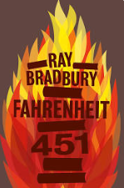
Fahrenheit 451 by Ray Bradbury

Fahrenheit 451 is a dystopian novel which presents a future society in which books have been personified and outlawed and ‘firemen’ burn any that are found.

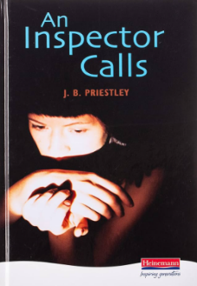
An Inspector Calls by J.B. Priestly

An Inspector Calls is a 1945 play focussing on the prosperous Birling family who live a comfortable, upper middle-class life. They are visited one evening by Inspector Goole who questions them about the suicide of a young working-class girl.

