Group: P16 Deepening |  |  | Subject: A-Level Language and Literature Y2+ | Term: 2
Teacher: |  | Molly Vellacott
Curriculum: HE Ready 3
Term 2 focus:
HT1: Unseen non-fiction; Anthology question, writing skills
HT2: Responsive revision; a last look at the coursework

This term we will be refining our writing about unseen non-fiction texts on the theme of love and loss, and revising the non-fiction anthology and the comparative writing element for this.

As the theme for this section of the exam is Love and Loss, our explorations will use this as a lens to examine a variety of aspects of the texts and look at how writers tackle these themes in general, gaining confidence to talk and write about how individual authors explore them in particular. Our big questions are: what meanings are present in the texts and how are the meanings made? We will explore the answers using concepts and methods from integrated linguistic and
literary study.

We will develop our writing style, ensuring that we can control the depth and extent of our analytical writing, and maintain clarity and succinctness. We will also hone our comparative skills, gain more familiarity with the extended essay form required, and build confidence to find our individual voices within the requirements.

1 | Apply concepts and methods from integrated linguistic and  literary study as appropriate, using associated terminology  and coherent written expression
2 | Analyse ways in which meanings are shaped in texts
3 | Demonstrate understanding of the significance and influence  of the contexts in which texts are produced and received
4 | Explore connections across texts, informed by linguistic and  literary concepts and methods
5 | Demonstrate expertise and creativity in the use of English to  communicate in different ways
6 | Ask for assistance or clarification appropriately and effectively
7 | Contribute to class discussion to assist own and others’ understanding and interpretation
8 | Independently generate original ideas and responses to stimuli
Tier Three Keywords:
Pragmatics | Voice | Self-awareness | Discourse marker | Epistolary | Structure
Narrative perspective | Narrative shift | Context | Semantic field
Recommended Reading:

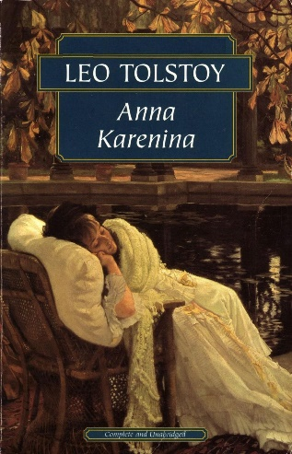
You are encouraged and expected to read widely.

As a minimum, read Anna Karenina by Leo Tolstoy by the end of the term and tell me what you will be reading on your own account over the holidays.

In 1801, Mr Lockwood, the new tenant at Thrushcross Grange in Yorkshire, pays a visit to his landlord, Heathcliff at his remote moorland farmhouse, Wuthering Heights. There he meets a reserved young woman (Cathy Linton), Joseph, a cantankerous servant, and Hareton, an uneducated young man who speaks like a servant. Everyone is sullen and inhospitable. Snowed in for the night, Lockwood reads the diary of the former inhabitant of his room, Catherine Earnshaw, and has a nightmare in which a ghostly Catherine begs to enter through the window. Awakened by Lockwood's fearful yells, Heathcliff is troubled…

Expanding our ideas of love and loss, this gothic novel

