Group: NEM02 |  |  | Subject: English | Term: 2
Teacher: |  | Liz Lynch-Smith
Curriculum: Secondary Ready Fundamentals
Term 1 focus:
HT1 - Short stories and creative writing
In half-term one we are adopting a writing-for-pleasure approach, following research into how students can best enjoy writing and start to see themselves as writers. Taking the short story as our focus, we will be developing our reading skills – for example commenting on structure, and genre conventions – mainly in the service of our own writing. We will start by reading and analysing a range of fables to understand the genre, before planning, drafting and revising our own, with mini-lessons throughout the process (for example, on sentence types and writing dialogue) to help students improve their own writing before publishing it in a manner of their choosing.
HT2 - 20th century play
In half-term two we will be studying The Demon Headmaster as our 20th century play and we will be reading, performing and discussing the entire text. Our reading focus will be context (different types of education) and viewpoints (what Cross is trying to achieve with her work), and we will also concentrate on our speaking and listening skills, largely through discussion and debate.

Reading:
HT1: Structure
HT2: Discussion of ideas, themes and contemporary issues arising from the text.

KO2 | In most reading, simple most obvious points identified; some comments include quotations from or references to text
KO3 | In most reading, straightforward inference based on single point of reference; literal meaning established; personal speculation
KO4 | In most reading, a few basic features of organisation at text level identified
KO5 | In most reading, a few basic features of writer’s use of language identified
KO6 | In most reading, identifies main purpose; expresses personal response; emerging awareness of viewpoint, effect
KO7 | In most reading, some simple connections between texts identified; recognition of some features of the context of texts
Writing:
HT1: Creative
HT2: Writing to support talk

KO1 | In most writing, some appropriate ideas and elaboration; attempt to adopt viewpoint
KO3 | In most writing, some related points placed next to each other; openings, closings usually signalled; some logical sequencing
KO4 | In most writing, some structure and links between sentences within sections; emerging fluidity of movement between sections
KO5 | In most writing, mainly simply structured sentences, supported variation; common connectives; emerging tense, verb forms
KO7 | In most writing, simple, generally appropriate vocabulary used, limited in range; some words selected for effect or occasion

Tier Three Keywords:
infer | identify | structure | plot | character | scene
paragraph | genre | reader | author | narrator | 1st person/third person
act | stage directions | context

Recommended Reading:

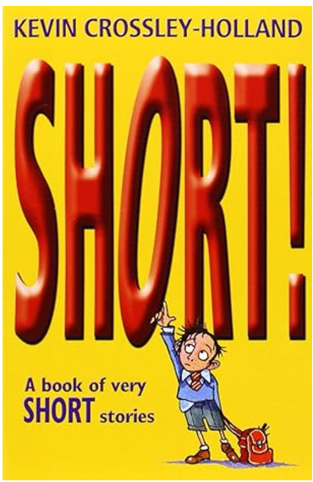
A collection of very short stories from award-winning author, Kevin Crossley-Holland. None of the stories is more than two pages long, and some are much shorter. There are stories about ghosts, supermarkets, animals, adventures, and all kinds of things to inspire every short story writer.

