Group: P16 Study Prog 3 |  |  | Subject: GCSE English Language resit | Term: 2
Teacher: |  | Helen Hawkins
Curriculum: Study Programme 3
Term 2 focus:
In half-term one we will focus on imaginative and transactional writing and technical accuracy.
In half-term two we will revisit the reading questions with particular focus on evaluation.
 | Reading
AO1 | - Identify and interpret explicit and implicit information and ideas  - Select and synthesise evidence from different texts
AO2 | Explain, comment on and analyse how writers use language and structure to achieve effects and influence readers, using relevant subject terminology to support their views
AO3 | Compare writers’ ideas and perspectives, as well as how these are conveyed, across two or more texts
AO4 | Evaluate texts critically and support this with appropriate  textual references
 | Writing
AO5 | - Communicate clearly, effectively and imaginatively, selecting and adapting tone, style and register for different forms, purposes and audiences  - Organise information and ideas, using structural and grammatical features to support coherence and cohesion of texts
AO6 | Candidates must use a range of vocabulary and sentence structures for clarity, purpose and effect, with accurate spelling and punctuation

Tier Three Keywords:
infer | identify | audience | context | purpose | analyse
viewpoint | purpose | evaluate | compare

Recommended Reading:

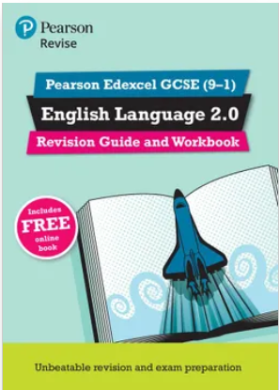
With both guidance for classroom and independent study, and exam-style questions to help develop skills and understanding of the assessment, this combined revision guide and workbook enables hassle-free classroom and independent study.
Pearson Edexcel GCSE (9-1) English Language 2.0. Revision Guide and Workbook Paperback edition by Jane Cotter, Ben Cribbin, Katy Madgwick

