Group: S2 Exploring |  |  | Subject: GCSE English Literature Y1 | Term: 2
Teacher: |  | Molly Vellacott
Curriculum: P16 Deepening
Term 2 focus:

This term we will be studying ‘The Merchant Of Venice’ by William Shakespeare. Students in the Tuesday group are invited to read ‘Boys Don’t Cry’ by Malorie Blackman, at home. We will read the play and watch the film in stages as we go along, with commentary and verbal questioning about character presentation, contextual issues and key themes. We will then revisit major themes and presentations with written responses to key extracts, while revising key plot points.

1 | Maintain a critical style and develop an informed personal response
2 | Use textual references, including quotations, to support and illustrate interpretations
3 | Analyse the language, form and structure used by a writer to create meanings and effects
4 | Use relevant subject terminology where appropriate
5 | Show understanding of the relationships between texts and the contexts in which they were written
6 | Use a range of vocabulary and sentence structures for clarity, purpose and effect
7 | Use accurate spelling and punctuation
9 | Ask for assistance or clarification appropriately and effectively
10 | Contribute to class discussion to assist own and others’ understanding and interpretation
11 | Independently generate original ideas and responses to stimuli

Tier Three Keywords:
connote | identify | structure | context | evidence | analyse
stereotype | form | evaluate | themes | prejudice | symbolism

Recommended Reading:

Mahon, John W. and Ellen Macleod Mahon. The Merchant of Venice: New Critical Essays. London: Routledge, 2002.

Slam by Nick Hornby

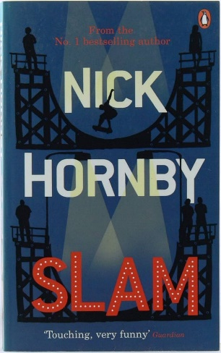
Sam is 16 and the child of a teenage mother, and the closest thing to a father in his life is a poster of the skater Tony Hawk. He doesn’t feel ready to become a father, and his mother certainly isn’t up for being a grandma. But a series of prophetic dreams and a new turn of reality which he doesn’t recognise seem to being trying to tell him something…

Enjoy the similar subject material to “Boys Don’t Cry” whilst exploring the extra layers of meaning and interest which the original structure lends to the text.

Where Angels Fear to Tread by EM Forster


On travelling to Italy with her friend Caroline Abbott, the impulsive English widow Lilia Herriton outrages her dead husband's family by meeting and quickly becoming engaged to Gino, a dashing but deeply unsuitable Italian man twelve years her junior. Infuriated, her ex-brother-in-law Philip sets off from England to her new home in the Tuscan town of Monteriano - but, finding himself unable to persuade Lilia to leave her handsome, uncouth new lover, returns to England without her. When Lilia's marriage leads to sudden tragedy, however, Philip and Caroline feel compelled to return once more to Italy, where they are forced to examine their own lives.

