Group: BR07 |  |  | Subject: English | Term: 2
Teacher: |  | Helen Hawkins
Curriculum: Study Programme 2 Deepening
Term 2 focus:
HT1: Short Stories and Creative Writing
We will read a small selection of short stories in order to explore conventions and structure. Students will then take on the role of the writer and develop their own ideas for a short story which they will draft and publish.
HT2: 20th century play and speaking and listening
We will study a contemporary play, developing understanding of dramatic conventions. Students will have lots of opportunities for performance and discussion.

Reading:
HT1: Structure.
HT2: Discussion of ideas, themes and contemporary issues arising from the text.
KO2 | Comments generally supported by relevant textual reference or quotation, even when points made are not always accurate
KO3 | Comments make inferences and deductions based on textual evidence
KO4 | Comments on structural choices show some general awareness of writer’s craft
KO5 | Various features of writer’s use of language identified, with some explanation
KO6 | General awareness of effect on the reader, with some, often limited, explanation
Writing:
HT1: Creative
HT2: Writing to support talk
KO1 | Relevant ideas and material developed with some imaginative detail
KO3 | Material is structured clearly, with sentences organised into appropriate paragraphs
KO4 | Paragraphs clearly structure main ideas across text to support purpose, e.g. clear chronological or logical links between paragraphs
KO5 | A variety of sentence lengths, structures and subjects provides clarity and emphasis
KO7 | vocabulary chosen for effect

Tier Three Keywords:
Narrator | Setting | Plot | Omniscient | Genre | Mood
Theme | Freytag | Cyclical structure | Foreshadowing | Tension | Conflict
Resolution | Exposition | Climax | Falling action | Rising action | Character

Recommended Reading:

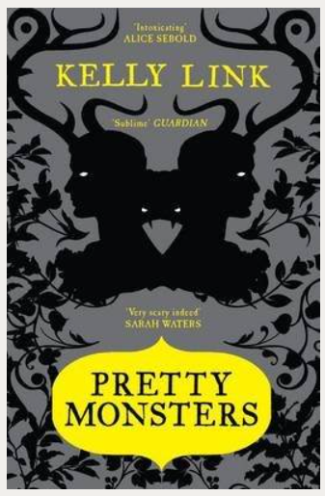
How could you possibly know that the decomposing corpse would stalk you and follow you home? And how are you going to explain it to your Mum?
The Wrong Grave is the first in this collection of short stories and sets the scene for what is to follow. With tales ranging from the macabre to the poignant and from the absurd to the mundane, many have undertones of wry humour and all are acutely observed and in some way unsettling or disturbing.
Ghosts, bloodthirsty monsters, mysterious wizards and aliens all assist with the author's metafictional manipulations, while simultaneously providing captivating entertainment.

