Group: NEMO2 |  |  | Subject:  Humanities | Term: 2
Teacher: |  | Beckie Howe
Curriculum: Secondary Ready Fundamentals
Term 2 focus: Weather & Climate – Norman Invasion
1 | I can name and explain the function of weather instruments.
2 | I can explain what causes the 3 types of rain.
3 | I can construct a climate graph.
4 | I am beginning to understand the impact of climate change.
5 | I can identify the worlds continents and oceans.
6 | I can explain why there was a crisis in 1066.
7 | I can explain why William won the Battle of Hastings.
8 | I know how life changed after the Norman conquest.
9 | I can explain why events may have differing interpretations.
10 | I can explain the similarities and differences between the Roman and Norman armies.
Tier Three Keywords:
Air mass | Air pressure | anemometer | barometer | Beaufort scale | Climate/weather
Okta | condensation | Heir | Cavalry | Witan | Housecarl
Peasant | Noble | Oath | Berserker | Norman | Viking
Recommended Reading:

Geog 2 – https://climatekids.nasa.gov/menu/weather-and-climate/

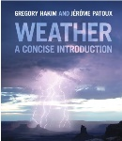
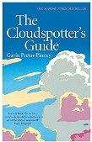
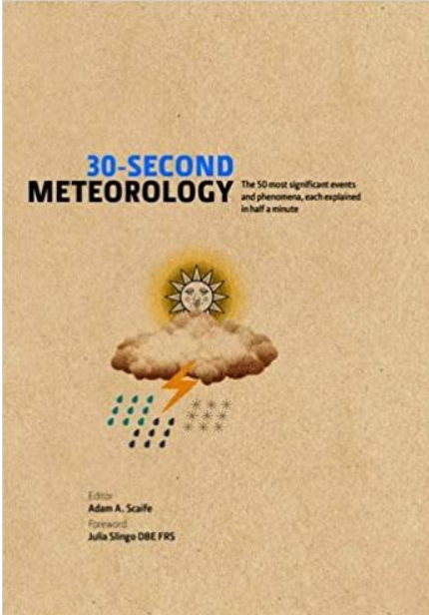

History- Normans Audio book



