Group: NEM04 |  | Subject: Mathematics | Term: 2
Teacher: | Ed Kirk and Liz Lynch-Smith
Curriculum: Secondary One: Fundamentals
Term 2 focus: This term we will ensure we are able to fluently use strategies for multiplying and dividing we will then explore working with fractions; adding, subtracting. We will then look at fractions of an amount and percentages of an amount using additive strategies and bar models.
 | Theme | Objective | Attendance | How I felt about it  
 |  |  | (Date unit finished) | End of  unit | 4 weeks later | End of term
1 | Theme 2 | I can fluently use efficient strategies for multiplying including with decimals
2 | Theme 2 | I can fluently use efficient strategies for dividing including with decimals
3 | Theme 2 | I understand the commutative, associative and distributive laws and use them to calculate efficiently
4 | Theme 2 | I can find a common denominator to add and subtract fractions
5 | Theme 2 | I can add and subtract fractions and mixed numbers
6 | Theme 3 | I can find a fraction of a given amount
7 | Theme 3 | I can find the whole amount when given the fraction of the amount
8 | Theme 3 | I can find multiples of 10% of an amount
9 | Theme 3 | I can find multiples of 5% of an amount
10 | Theme 3 | I can find any integer percentage of an amount

Tier Three Keywords:
numerator | denominator | improper fraction | mixed number | multiple
integer

Assessment:
Daily Assessment | Substantive Assessment
Type:  Formative assessment happens throughout mathematics lessons, questioning during modelling, encouraging students to explain and justify their working as well as checking work completed. | Type:  During recall lessons objectives will be assessed around 4 weeks after they have been taught in the form of low stakes tasks. Students will have the opportunity to show they are secure in their understanding. Where students are not yet secure, they will be given scaffolding and opportunities to show they are embedding, developing or beginning to use this knowledge.  Students will also attempt problem-solving tasks during recall lessons which give opportunities for them to apply their mathematics to a variety of routine and non-routine problems, giving them an opportunity to show their reasoning and problem-solving skills.

Recommended Reading:

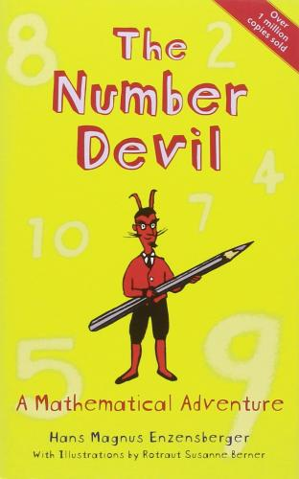
The Number Devil
Author
Hans Magnus Enzensberger
The quirky and unusual story of a young boy who hates maths at school, but who discovers a new side to the subject when he meets an unusual mathematician in a dream. This book takes you on an adventure through creative mathematical thinking, with great illustrations along the way.

Further resources:
Practice skills:
https://www.mathsgenie.co.uk/
https://www.mathslinks.co.uk/
https://corbettmaths.com/contents/
https://diagnosticquestions.com/

Problem solving:
https://nrich.maths.org/secondary-live-problems-and-recent-solutions
https://www.youcubed.org/tasks/
https://ukmt.org.uk/puzzles
https://www.cut-the-knot.org/
https://www.transum.org/Software/Puzzles/
https://www.mathsisfun.com/puzzles/index.html

