Group: EW02 |  | Subject: Mathematics | Term: 2
Teacher: | Ruth Coulson
Curriculum: Secondary Two: Exploring
Term 2 focus: We will cover topics from Theme 6: Geometry, Theme 3: Multiplicative reasoning and Theme 5: Statistics and probability. We will be using the rules for the area and circumference of a circle to then look at volume and surface area of a cylinder. We will look at ratio and use ratio tables to solve ‘best buy problems’.
 | Theme | Objective | Attendance | How I felt about it  
 |  |  | (Date unit finished) | End of  unit | 4 weeks later | End of term
1 | Theme 6 | I can find missing angles in triangles
2 | Theme 3 | I can use Pythagoras' theorem to find a missing side in a right-angled triangle
3 | Theme 6 | I can calculate area and circumference of a circle
4 | Theme 6 | I understand and can use the volume of cylinder
5 | Theme 6 | I understand and can use the surface area of a cylinder
6 | Theme 6 | I understand and can represent vectors
7 | Theme 3 | I can share a quantity in a ratio
8 | Theme 3 | I can solve 'best buy' problems
9 | Theme 3 | I can find the percentage of an amount
10 | Theme 3 | I can calculate simple and compound interest

Tier Three Keywords:
circumference | radius | vector | ratio | pi
compound | interest | probability

Assessment:
Daily Assessment | Substantive Assessment
Type:  Formative assessment happens throughout mathematics lessons, questioning during modelling, encouraging students to explain and justify their working as well as checking work completed. | Type:  During recall lessons objectives will be assessed around 4 weeks after they have been taught in the form of low stakes tasks. Students will have the opportunity to show they are secure in their understanding. Where students are not yet secure, they will be given scaffolding and opportunities to show they are embedding, developing or beginning to use this knowledge.  Students will also attempt problem-solving tasks during recall lessons which give opportunities for them to apply their mathematics to a variety of routine and non-routine problems, giving them an opportunity to show their reasoning and problem-solving skills.

Recommended Reading:
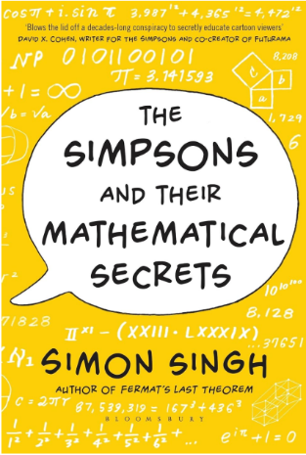
The Simpson’s and their Mathematical Secrets by Simon Singh
Singh shows a knack for gliding seamlessly between abstract mathematical concepts and every day life, always seeking out the most engaging, human and topical examples. Singh's clean prose, detailed research and enthusiasm for the world of numbers are likely to captivate even those for whom maths normally creates feelings of anxiety rather than mirth.
A valuable, entertaining book that, above all, celebrates a supremely funny, sophisticated show

Further resources:
Practice skills:
https://www.mathsgenie.co.uk/
https://www.mathslinks.co.uk/
https://corbettmaths.com/contents/
https://diagnosticquestions.com/

Problem solving:
https://nrich.maths.org/secondary-live-problems-and-recent-solutions
https://www.youcubed.org/tasks/
https://ukmt.org.uk/puzzles
https://www.cut-the-knot.org/
https://www.transum.org/Software/Puzzles/
https://www.mathsisfun.com/puzzles/index.html

