AS |  | Biology |  | Term 2  January-March2025
Teacher : |  |  | Nayna
Transport across membranes
1 | The basic structure of all cell membranes, including cell-surface membranes and the membranes around the cell organelles of eukaryotes, is the same.  The cell membrane consists of a lipid bilayer, made up of two layers of phospholipids with cholesterols (a lipid component) interspersed between them, maintaining appropriate membrane fluidity at various temperatures.
2 | The arrangement and any movement of phospholipids, proteins, glycoproteins and glycolipids in the fluid-mosaic model of membrane structure. Cholesterol may also be present in cell membranes where it restricts the movement of other molecules making up the membrane.  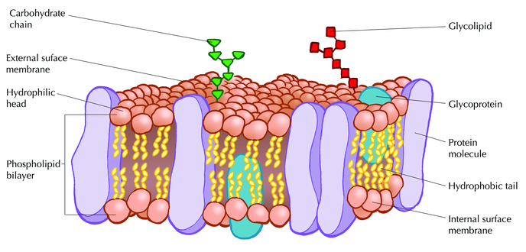
3 | Movement across membranes occurs by:  *Simple diffusion  Diffusion is the net movement of anything generally from a region of higher concentration to a region of lower concentration. Diffusion is driven by the presence of a concentration gradient  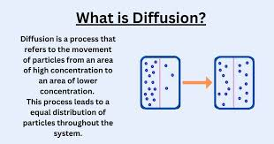  *Facilitated diffusion (involving the roles of carrier proteins and channel proteins)  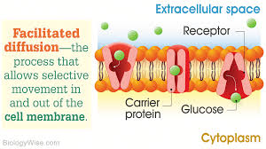  *Osmosis (explained in terms of water potential)  Osmosis is a process where water molecules move from an area of low solute concentration to high solute concentration through a semipermeable membrane. This movement can be influenced by factors such as solute size and charge.  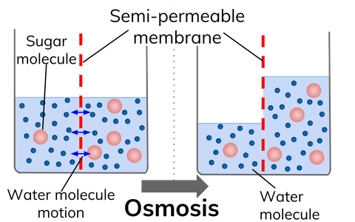  Additional notes:  *Active transport (involving the role of carrier proteins and the importance of the hydrolysis of ATP)  Active transport is the movement of molecules across a biological membrane from an area of lower concentration to an area of higher concentration, against the concentration gradient, with the assistance of energy.  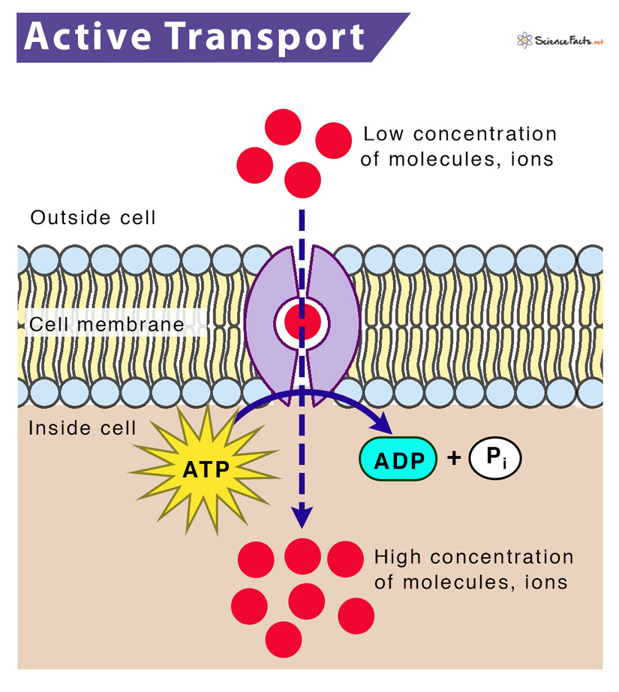  Additional notes:  *Co-transport (illustrated by the absorption of sodium ions and glucose by cells lining the mammalian ileum).  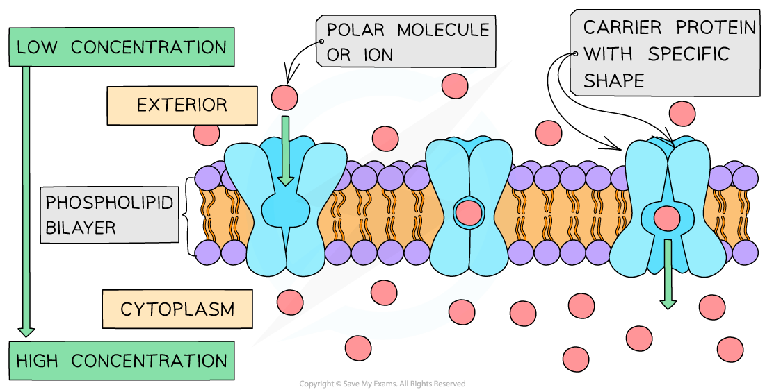  Additional notes
4 | Cells may be adapted for rapid transport across their internal or external membranes by an increase in surface area of, or by an increase in the number of protein channels and carrier molecules in, their membranes.  Single celled organisms have a very large surface area to volume ratio, however large organisms on the other hand have a greater volume, with a smaller increase in surface area. Therefore, the rate of diffusion would be too slow in large organism to provide all of the transport. Therefore, these organisms require a transport system  Adaptations of exchange surfaces to maximise exchange  In multicellular organisms, surfaces and body organs are specialised for exchanging materials.  *The ability to maximise exchange of substances in as short a time as possible in plants and animals is increased by having:  - A large surface area to volume ratio  - The flattened shape of structures such as leaves.  - The alveoli in the respiratory system.  - The villi in the digestive system.  A short distance required for diffusion to and from cells, when the cell membrane is very thin, as in:  - The flattened shape of structures such as leaves.  - The walls of blood capillaries, which are one cell thick. The epithelia of alveoli in the respiratory system, and the villi in the small intestine, which are one cell thick.
5. | Students should be able to:  - Explain the adaptations of specialised cells in relation to the rate of transport across their internal and external membranes  - Explain how surface area, number of channel or carrier proteins and differences in gradients of concentration or water potential affect the rate of movement across cell membranes.
6. | Required practical 3: Production of a dilution series of a solute to produce a calibration curve with which to identify the water potential of plant tissue.  Required practical 4: Investigation into the effect of a named variable on the permeability of cell-surface membranes.

