Group: NEC05, NEC06 and NEC07 |  |  | Subject: English | Term: 3
Teacher: |  | Helen Hawkins
Curriculum: Secondary One Exploring
Term 3 focus:
HT1: Shakespeare – Macbeth
We will use the original text and film versions to help us understand and appreciate the plot and big ideas in the play. We will study selected extracts in more detail, focusing on Shakespeare’s use of language. We will learn how to write analytically about the play.
HT2: Poetry
We will study a range of poetry by different writers, learning about different poetic methods and forms. We will then our own poetry.

Reading:
HT1: Structure.
HT2: Discussion of ideas, themes and contemporary issues arising from the text.
KO1 | Range of strategies used mostly effectively to read with fluency, understanding and expression
KO3 | Make inferences based on evidence from different points in the text, often correct
KO4 | Some structural choices identified with simple comment; identifies some basic organisational features
KO5 | Some basic language features identified; simple comments on writer’s choices
KO6 | Simple comment on overall effect on reader
KO7 | Simple comment identifies common features and effect that the reader’s or writer’s context has on the meaning
Writing:
HT1: Creative
HT2: Writing to support talk
KO1 | Relevant ideas and content chosen
KO2 | Main purpose and features clear; appropriate to purpose; style generally appropriate, some awareness of reader
KO3 | Ideas organised simply by clustering related points/ time sequence; sequencing generally logical; some signalling
KO5 | Some variety in length, structure or subject of sentences
KO7 | Some evidence of deliberate vocabulary choices; some expansion of general vocabulary to match topic

Tier Three Keywords:

Shakespeare | play | tragedy | imagery | meter | Jacobean
patriarchy | stanza | metaphor | onomatopoeia | alliteration | personification

Recommended Reading:
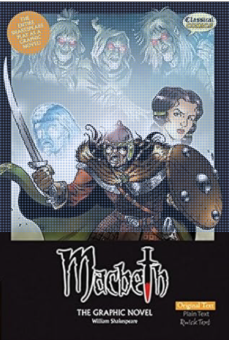
This is William Shakespeare's full and unabridged play in comic book form. This full colour graphic novel presents "The Scottish Play" just as Shakespeare intended: in its original and unabridged format. Ideal for purists, students and readers who will appreciate the unaltered text. "Macbeth" is probably the most dramatic of Shakespeare's tragedies and this version will give you a brand new and totally fulfilling view of the sheer genius of Shakespeare's story telling. Witchcraft, superstition, murder - it's all here! Featuring stunning artwork, and full of action, atmosphere and intrigue from start to finish; this new treatment of The Bard's wonderful tragedy will have you on the edge of your seat.

