Group: BR02 |  |  | Subject: English | Term: 3
Teacher: |  | Joanne Pearce
Curriculum: Secondary Two Fundamentals
Term 1 focus:
HT1 - Shakespeare – Romeo and Juliet
HT2 - Poetry
Reading:
HT5: Understanding the text and using evidence
HT2: Enjoying the text

KO1 | Successfully manage new words using a range of strategies.
KO3 | Across a range of texts comments develop explanation of inferred meanings draws on varied evidence across the text
KO4 | Across a range of reading, some general awareness of writer’s craft re: structural choices; organisational features identified, explanation
KO5 | Across a range of reading, features of language use identified, with some explanation; some awareness of language choices
KO6 | Across a range of reading, main purpose, viewpoint clearly identified, general overview; general awareness of effect, some explanation
KO7 | Across a range of reading, some explanation identifies similarities, differences between texts; and of how contexts contribute to meaning
Writing:
HT1: Effective organisation of ideas and evidence
HT2: Writing poetry

KO1 | Across a range of writing, some imaginative ideas; material appropriately shaped; clear viewpoint, generally consistent
KO2 | Across a range of pieces, clear purpose; features of form show some adaptation to purpose; appropriate style maintains reader’s interest
KO3 | Across a range of writing, material structured clearly; paragraphs; development of material; direction signalled by links between paragraphs
KO5 | Across a range of writing, variety of sentences for clarity, emphasis; connectives for idea relationship; some structure for detail, nuance
KO7 | Across a range of writing, vocabulary chosen for effect; reasonably wide vocabulary used, often appropriately

Tier Three Keywords:
infer | identify | structure | plot | character | scene
playwright | Elizabethan | Iambic pentameter | verse | meter | gender
Elizabethan | metaphor | imagery | stanza

Recommended Reading:

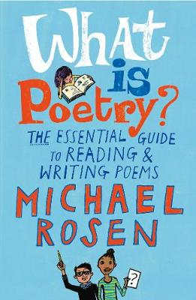
Over many years as a working poet, Michael Rosen has thought a great deal about what poems are, what they can do and the pleasure that comes from writing and reading poetry. In this invaluable handbook, he shares this knowledge and experience in book form for the very first time. Starting with a detailed analysis of a number of classic poems, he offers a real “writer’s guide” to writing and performing poems, as well as a wealth of technical information and tips. He then takes a fascinating look at a selection of his own poems and explains how and why he wrote them.

